**Project Design Phase-I**

**Solution Architecture**

|  |  |
| --- | --- |
| Date | 19 September 2022 |
| Team ID | PNT2022TMID27345 |
| Project Name | Fertilizers Recommendation System For Disease Prediction |
| Maximum Marks | 4 Marks |

**Solution Architecture:**

Solution architecture is a complex process – with many sub-processes – that bridges the gap between business problems and technology solutions. Its goals are to:

* Find the best tech solution to solve existing business problems.
* Describe the structure, characteristics, behaviour, and other aspects of the software to project stakeholders.
* Define features, development phases, and solution requirements.
* Provide specifications according to which the solution is defined, managed, and delivered.

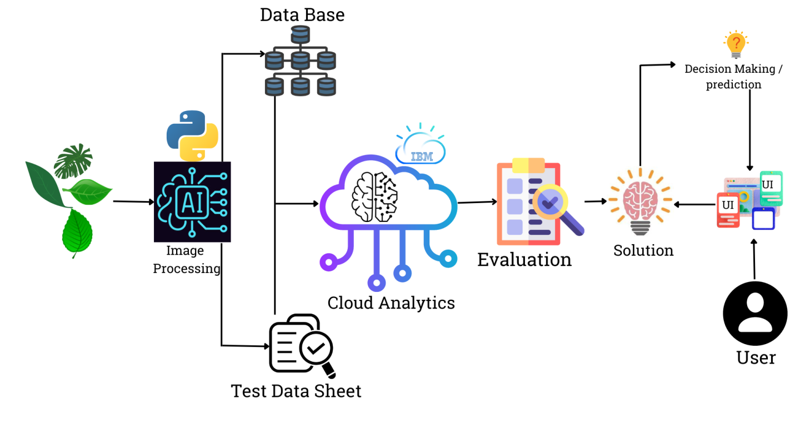

Agriculture is the most important sector in today’s life. Most plants are affected by a wide variety of bacterial and fungal diseases. Diseases on plants placed a major constraint on the production and a major threat to food security. Hence, early and accurate identification of plant diseases is essential to ensure high quantity and best quality. In recent years, the number of diseases on plants and the degree of harm caused has increased due to the variation in pathogen varieties, changes in cultivation methods, and inadequate plant protection techniques.

An automated system is introduced to identify different diseases on plants by checking the symptoms shown on the leaves of the plant. Deep learning techniques are used to identify the diseases and suggest the precautions that can be taken for those diseases.